Nama : Achmad Isra M
NIM : 221080200070

Script :
import 'package:flutter/material.dart';

void main() {
runApp(MyShopMini());
}

class MyShopMini extends StatelessWidget {
@override
Widget build(BuildContext context) {
return MaterialApp(
title: "MyShop Mini",
theme: ThemeData(primarySwatch: Colors.blue),
home: HomeScreen(),
);
}
}

// =============================
// MODEL DATA
// =============================
class Category {
final String name;
final IconData icon;

Category(this.name, this.icon);
}

class Product {
final String name;
final IconData icon;
final double price;

Product(this.name, this.icon, this.price);
}

// contoh kategori
final categories = [
Category("Makanan", Icons.fastfood),
Category("Minuman", Icons.local_drink),
Category("Elektronik", Icons.devices),
];

// contoh produk per kategori
final productData = {
"Makanan": [
Product("Nasi Goreng", Icons.restaurant, 15000),
Product("Bakso", Icons.local_pizza, 12000),
Product("Sate Ayam", Icons.local_dining, 20000),
],
"Minuman": [
Product("Es Teh", Icons.wine_bar, 5000),
Product("Kopi", Icons.emoji_food_beverage, 8000),
Product("Susu", Icons.local_cafe, 9000),
],
"Elektronik": [
Product("Laptop", Icons.laptop, 7000000),
Product("Headset", Icons.headset, 300000),
Product("Kamera", Icons.camera_alt, 2500000),
],
};

// =============================
// HOME SCREEN
// =============================
class HomeScreen extends StatelessWidget {
@override
Widget build(BuildContext context) {
return Scaffold(
appBar: AppBar(title: Text("MyShop Mini")),
body: Column(
children: [
SizedBox(height: 20),
Text(
"Pilih Kategori",
style: TextStyle(fontSize: 20, fontWeight: FontWeight.bold),
),
SizedBox(height: 20),
Row(
mainAxisAlignment: MainAxisAlignment.spaceEvenly,
children: categories.map((category) {
return GestureDetector(
onTap: () {
Navigator.push(
context,
MaterialPageRoute(
builder: (_) => ProductListScreen(category: category),
),
);
},
child: Card(
elevation: 4,
child: Container(
width: 100,
height: 120,
padding: EdgeInsets.all(10),
child: Column(
mainAxisAlignment: MainAxisAlignment.center,
children: [
Icon(category.icon, size: 40),
SizedBox(height: 10),
Text(category.name),
],
),
),
),
);
}).toList(),
),
],
),
);
}
}

// =============================
// PRODUCT LIST SCREEN
// =============================
class ProductListScreen extends StatelessWidget {
final Category category;

ProductListScreen({required this.category});

@override
Widget build(BuildContext context) {
final products = productData[category.name]!;

return Scaffold(
appBar: AppBar(title: Text(category.name)),
body: Column(
children: [
SizedBox(height: 10),
Text(
"Daftar Produk",
style: TextStyle(fontSize: 20, fontWeight: FontWeight.bold),
),
Expanded(
child: GridView.count(
crossAxisCount: 2,
children: products.map((product) {
return GestureDetector(
onTap: () {
Navigator.push(
context,
MaterialPageRoute(
builder: (_) => ProductDetailScreen(product: product),
),
);
},
child: Card(
elevation: 3,
child: Column(
mainAxisAlignment: MainAxisAlignment.center,
children: [
Icon(product.icon, size: 50),
SizedBox(height: 10),
Text(product.name),
Text("Rp ${product.price.toInt()}"),
],
),
),
);
}).toList(),
),
),
],
),
);
}
}

// =============================
// PRODUCT DETAIL SCREEN
// =============================
class ProductDetailScreen extends StatelessWidget {
final Product product;

ProductDetailScreen({required this.product});

@override
Widget build(BuildContext context) {
return Scaffold(
appBar: AppBar(title: Text(product.name)),
body: Center(
child: Column(
mainAxisAlignment: MainAxisAlignment.center,
children: [
Icon(product.icon, size: 100),
SizedBox(height: 20),
Text(product.name, style: TextStyle(fontSize: 24)),
SizedBox(height: 10),
Text("Rp ${product.price.toInt()}", style: TextStyle(fontSize: 20)),
],
),
),
);
}
}

PENJELASAN SETIAP SCRIPT

Fungsi main() dan MyShopMini
void main() {
runApp(MyShopMini());
}
- Fungsi main() adalah pintu masuk aplikasi Flutter.
- runApp() menjalankan widget utama aplikasi, yaitu MyShopMini.
class MyShopMini extends StatelessWidget {
@override
Widget build(BuildContext context) {
return MaterialApp(
title: "MyShop Mini",
theme: ThemeData(primarySwatch: Colors.blue),
home: HomeScreen(),
);
}
}
- MyShopMini adalah widget utama aplikasi.
- Menggunakan MaterialApp sebagai kerangka UI.
- home: HomeScreen() menjadikan halaman pertama adalah HomeScreen.
- Tema warna aplikasi menggunakan biru.

Model Data (Category dan Product)
class Category {
final String name;
final IconData icon;

Category(this.name, this.icon);
}
Category memiliki:
- name → Nama kategori (misal: Makanan)
- icon → Ikon kategori

class Product {
final String name;
final IconData icon;
final double price;

Product(this.name, this.icon, this.price);
}
Product memiliki:
- name → Nama produk
- icon → Ikon produk
- price → Harga produk (double)

Data Dummy Kategori & Produk
final categories = [
Category("Makanan", Icons.fastfood),
Category("Minuman", Icons.local_drink),
Category("Elektronik", Icons.devices),
];
→ Array berisi 3 kategori.

final productData = {
"Makanan": [ ... ],
"Minuman": [ ... ],
"Elektronik": [ ... ],
};
→ Map yang memetakan nama kategori ke daftar produk.
Contoh:
- Kategori Makanan punya Nasi Goreng, Bakso, Sate Ayam.
- Kategori Minuman punya Es Teh, Kopi, Susu.

Home Screen
class HomeScreen extends StatelessWidget {
Ini halaman utama aplikasi.

Tampilan utama HomeScreen
- Ada judul: “Pilih Kategori”
- Ditampilkan dalam Card yang bisa ditekan (GestureDetector)
children: categories.map((category) {
return GestureDetector(
onTap: () {
Navigator.push(
context,
MaterialPageRoute(
builder: (_) => ProductListScreen(category: category),
),
);
},
Penjelasan:
- GestureDetector menangani klik pengguna.
- Saat kategori ditekan → pindah ke ProductListScreen sambil membawa data kategori.
child: Card(
elevation: 4,
child: Container(
width: 100,
height: 120,
padding: EdgeInsets.all(10),
- Menggunakan Card untuk tampilan kategori.
- Lebar 100, tinggi 120.

children: [
Icon(category.icon, size: 40),
SizedBox(height: 10),
Text(category.name),
]
- Menampilkan ikon kategori dan namanya.

Product List Screen (Daftar Produk)
final products = productData[category.name]!;
- Mengambil daftar produk sesuai kategori yang dipilih.

Tampilan daftar produk
Menggunakan GridView.count:
Expanded(
child: GridView.count(
crossAxisCount: 2,
children: products.map((product) {
- crossAxisCount: 2 → grid 2 kolom.
- Setiap produk ditampilkan dalam Card.

Ketika produk ditekan:
onTap: () {
Navigator.push(
context,
MaterialPageRoute(
builder: (_) => ProductDetailScreen(product: product),
),
);
},
→ Pindah ke halaman detail produk.

Tampilan setiap produk:
Icon(product.icon, size: 50),
Text(product.name),
Text("Rp ${product.price.toInt()}"),
- Menampilkan ikon, nama, dan harga.

Product Detail Screen (Detail Produk)
class ProductDetailScreen extends StatelessWidget {
final Product product;
- Menerima satu produk dari ProductListScreen.

Isi tampilan:
Icon(product.icon, size: 100),
Text(product.name, style: TextStyle(fontSize: 24)),
Text("Rp ${product.price.toInt()}", style: TextStyle(fontSize: 20)),
- Menampilkan ikon besar, nama produk, dan harga.

Hasil dari program diatas
Pilih kategori
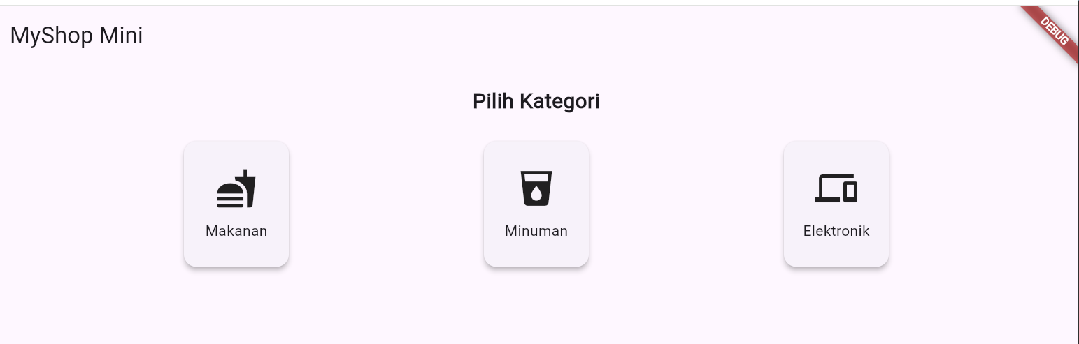
Ketika di buka bagian makanan
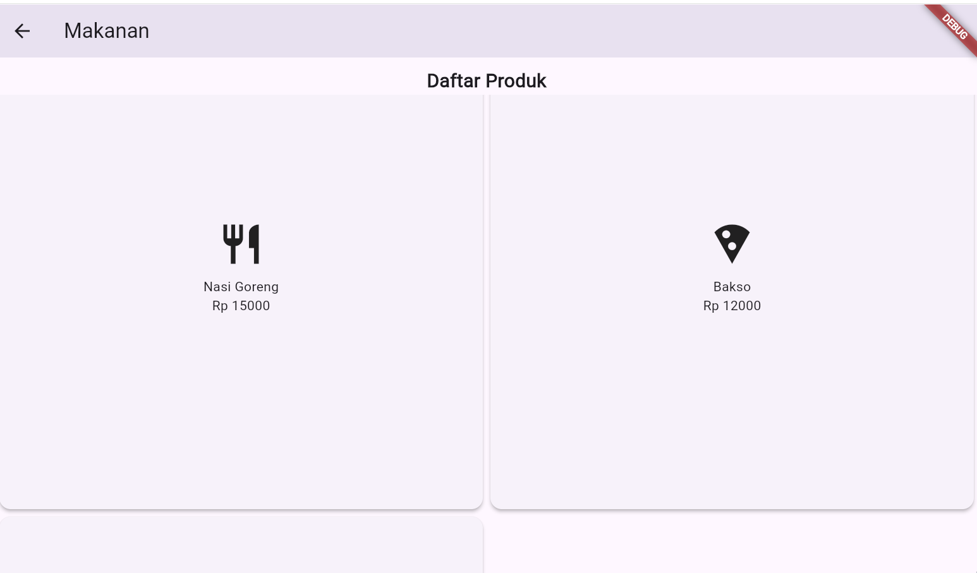

Ketika ingin melihat detail kategori
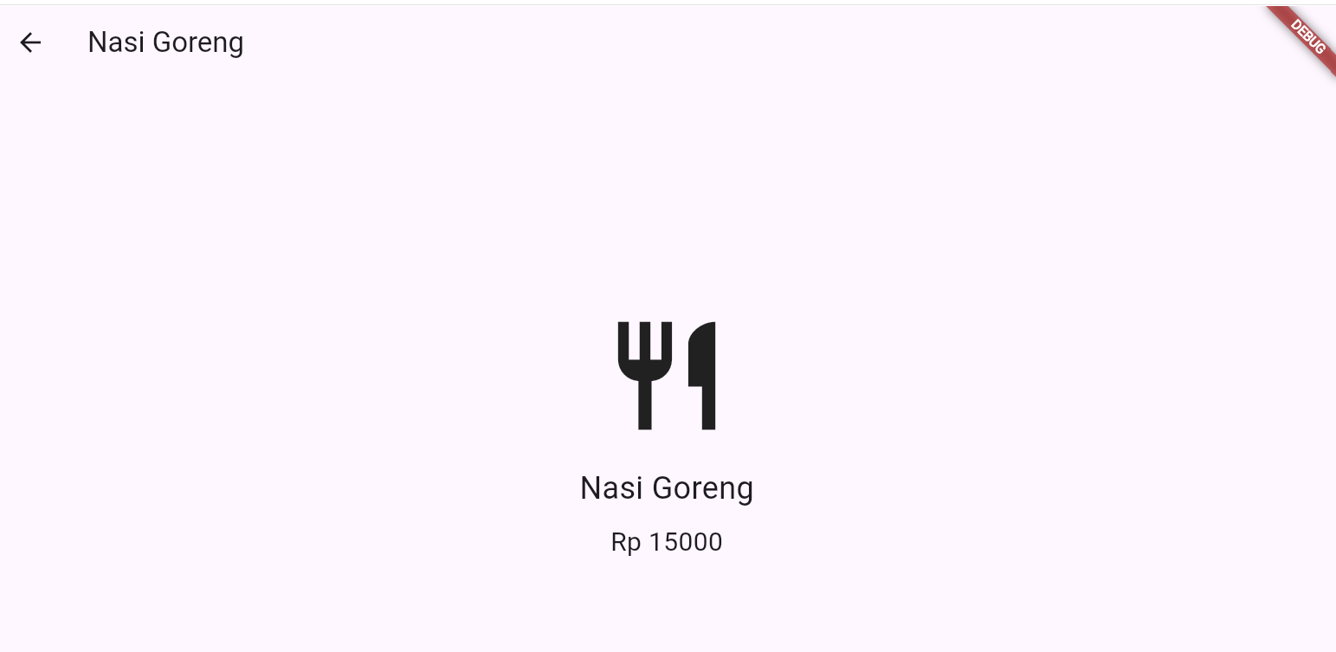
Kategori minuman
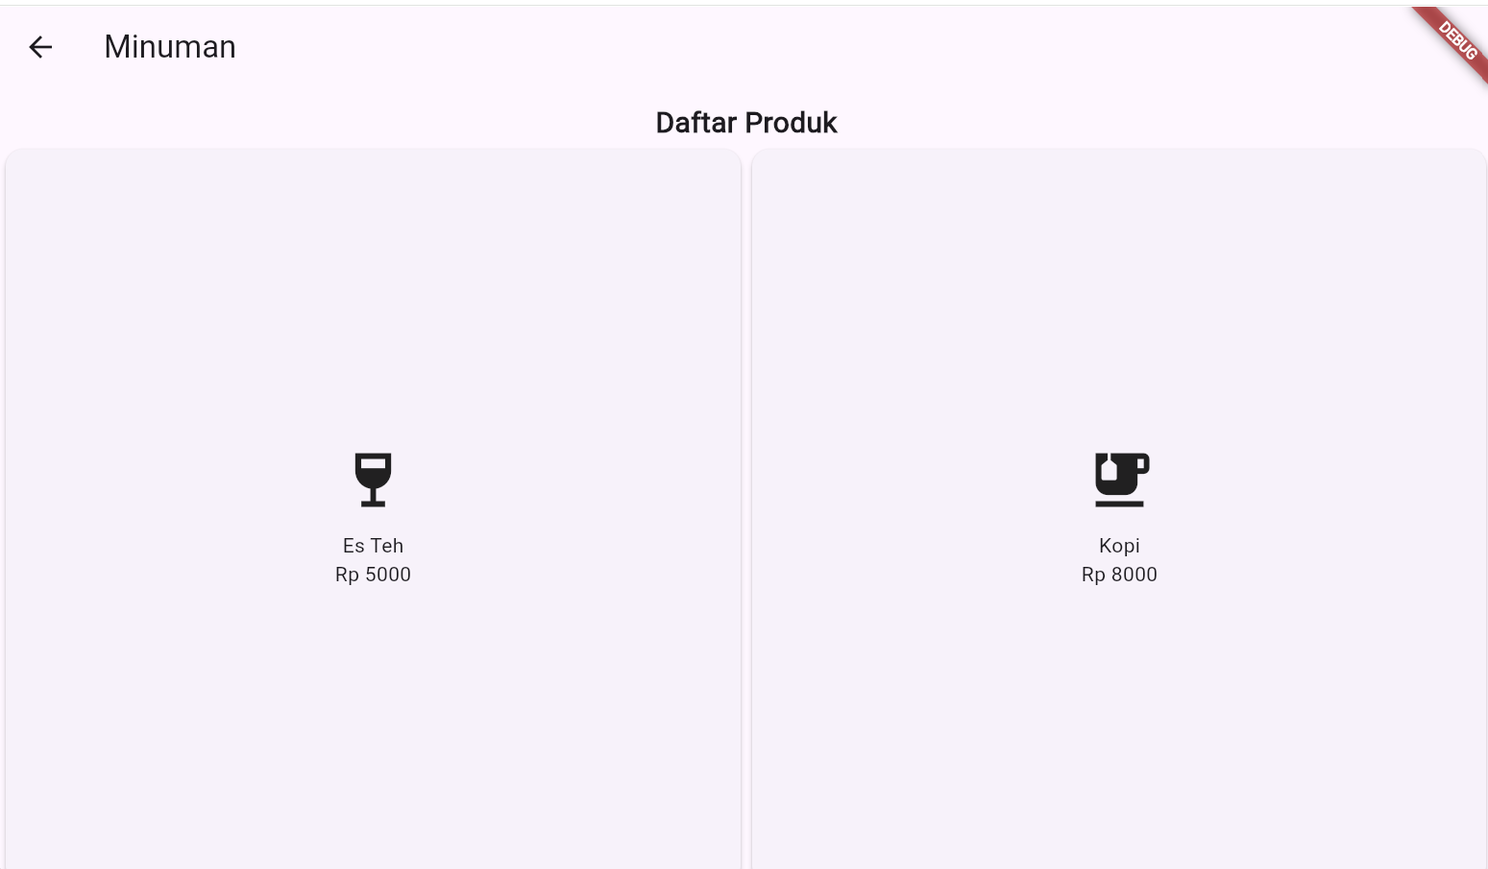

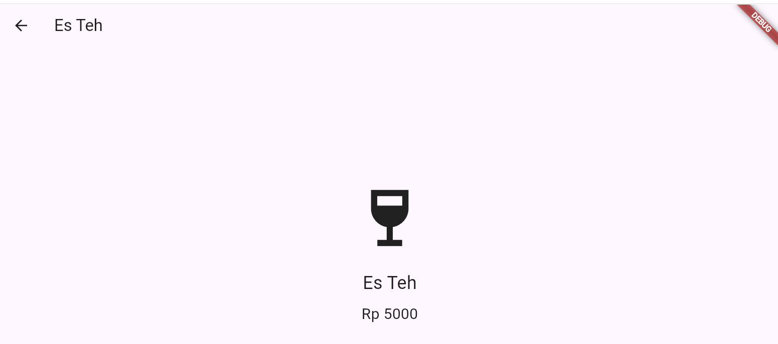
Kategori elektronik
